NIPWG8-49.4
Paper for Consideration by NIPWG
Proposal to Add Tides and Water Flow Forecasting Services to the S-123
Submitted by China Maritime Safety Administration (China MSA)
§
SUMMARY
Executive Summary: Advising the NIPWG to consider adding Tides and Water Flow(Tidal Stream and Current) forecasting services to the S-123, enriching Marine Radio Service Products, thereby contributing to the safety of navigation.
Action to be taken: paragraph 3
Related Documents: S-123 Version 1.0.0
- Introduction / Background

S-123 version 1.0.0 was released in January 2019. This is a publication dedicated to marine Radio Services, which can clearly inform navigators of the extent and nature of Radio Services, and it will ensure the security of navigation. However, in the current category of maritime broadcast, there are navigation warning, meteorological warning etc., and there is a lack of Tides and Water Flow Forecasting.
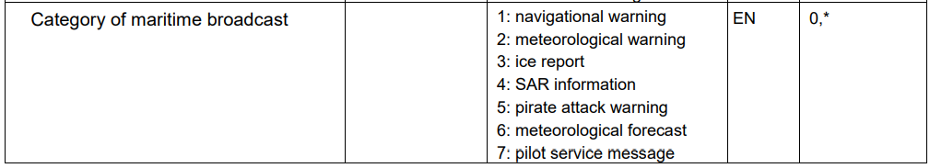
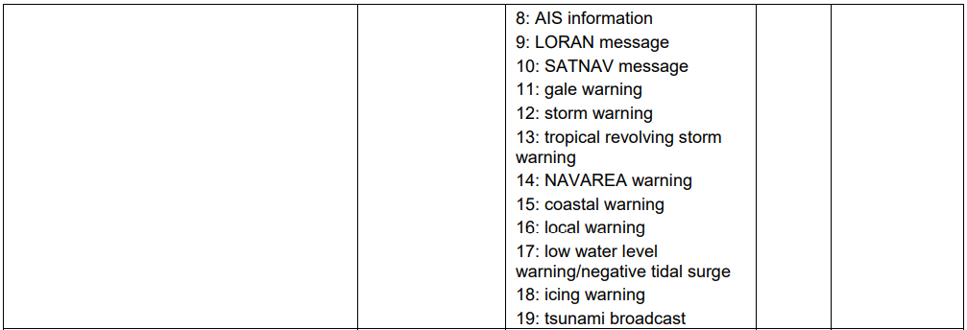

- Analysis

Tides and Water Flow (tidal streams and currents) Forecasts is very important to the navigator. Especially the water flow forecast, which is directly related to ship navigation and berthing. The S-44 also suggests that the speed and direction of water flows (tidal streams and currents) which may exceed 0.5 knots should be observed in key areas, if not already defined. For example, at the entrances to harbours and channels, at any change in direction of a channel, in anchorages, and adjacent to wharf areas. Timely provision of this information to the navigators can help to ensure the safety of navigation. So it is necessary to add Tides and Water Flow Forecasting Services to the S-123.

Many member states provide tides information via AIS, it is technically feasible to use radio to provide tides and water flow forecasting services. The tides and water flow forecast information types have been stipulated in the S-104 and S-111. The Feature Type of the tides and water flow forecast station and service areas can be set with reference to weather forecast station.

- Action required of NIPWG

The NIPWG is invited to note this document.

